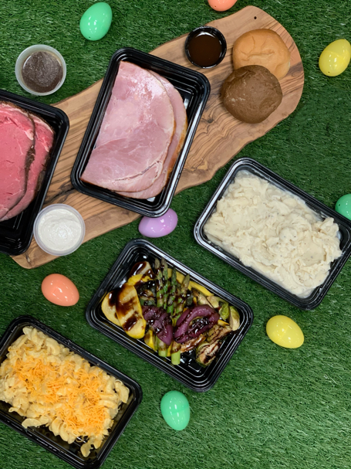

EASTER DINNER

**To place your order go to www.freshtastemealprep.com**

**All orders must be submitted by 3pm on Thursday, April 9th for Pick Up or Delivery on**

**Sunday, April 12th.**

**Pick Up Location & Time: BLT Kitchens, 739 E Dunlap Street, Phoenix, AZ 85020 – 9am to 5pm**

**Deliveries & Time:**

**Deliveries will be made from 10am-2pm**

**Delivery Fee within 15 miles of 85020 is $5. Deliveries outside of 85020, additional fees may apply.**

***Please consider donating during this holiday season for Phoenix Children’s Hospital. $20 = One Meal***

**Dinner for 4 - $99**

1 lb Rosemary Crusted Prime Rib Served w/

Ajou & Horseradish Cream

2 lb Smoked Honey Glazed Ham

**Dinner for 2 - $54**

½ lb Rosemary Crusted Prime Rib Served w/

Ajou & Horseradish Cream

1 lb Smoked Honey Glazed Ham

**ALL Dinners Include**

Three Cheese Mac and Cheese

Roasted Farm Vegetables

Mashed Potatoes

Freshly Baked Rolls

Tiramisu

**Additonal Sides (For 2) - $8**

Green Bean Casserole

Sweet Potato Casserole

Herb Stuffing

Freshly Baked Rolls (4)

Mashed Potatoes

Roasted Farm Vegetables

Three Cheese Mac & Cheese

Tiramisu (2 slices)