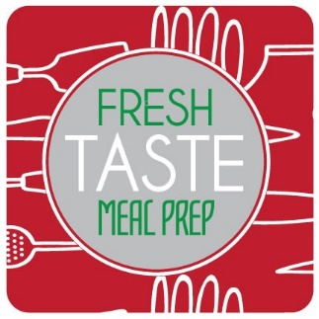
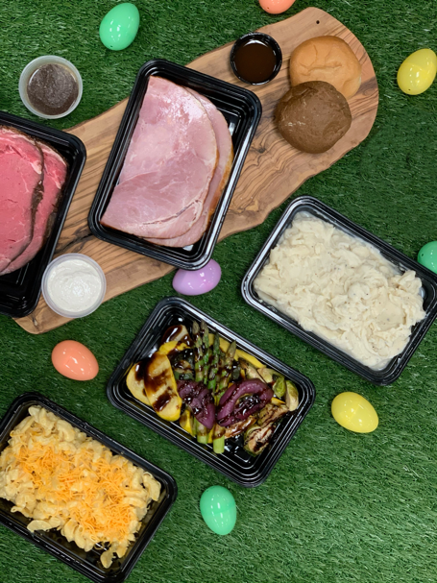


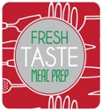
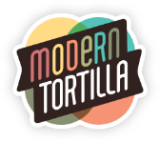
EASTER DINNER

To place your order go to www.freshtastemealprep.com
All orders must be submitted by 3pm on Thursday, April 9th for Pick Up or Delivery on
Sunday, April 12th.
Pick Up Location & Time: BLT Kitchens, 739 E Dunlap Street, Phoenix, AZ 85020 – 9am to 5pm
Deliveries & Time:
Deliveries will be made from 10am-2pm
Delivery Fee within 15 miles of 85020 is $5. Deliveries outside of 85020, additional fees may apply.
Please consider donating during this holiday season for Phoenix Children’s Hospital. $20 = One Meal

Dinner for 4 - $99
1 lb Rosemary Crusted Prime Rib Served w/
Ajou & Horseradish Cream
2 lb Smoked Honey Glazed Ham

Dinner for 2 - $54
½ lb Rosemary Crusted Prime Rib Served w/
Ajou & Horseradish Cream
1 lb Smoked Honey Glazed Ham

ALL Dinners Include
Three Cheese Mac and Cheese
Roasted Farm Vegetables
Mashed Potatoes
Freshly Baked Rolls
Tiramisu

Additonal Sides (For 2) - $8
Green Bean Casserole
Sweet Potato Casserole
Herb Stuffing
Freshly Baked Rolls (4)
Mashed Potatoes
Roasted Farm Vegetables
Three Cheese Mac & Cheese
Tiramisu (2 slices)

